**Building and Maintaining an Amazon S3 Metadata using DynamoDB**

**Architecture**:

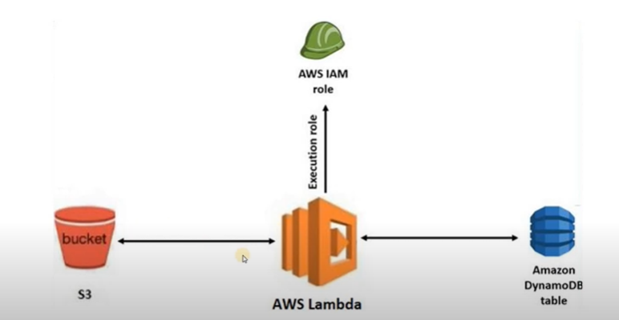

1. Create IAM Role for Lambda with policies-

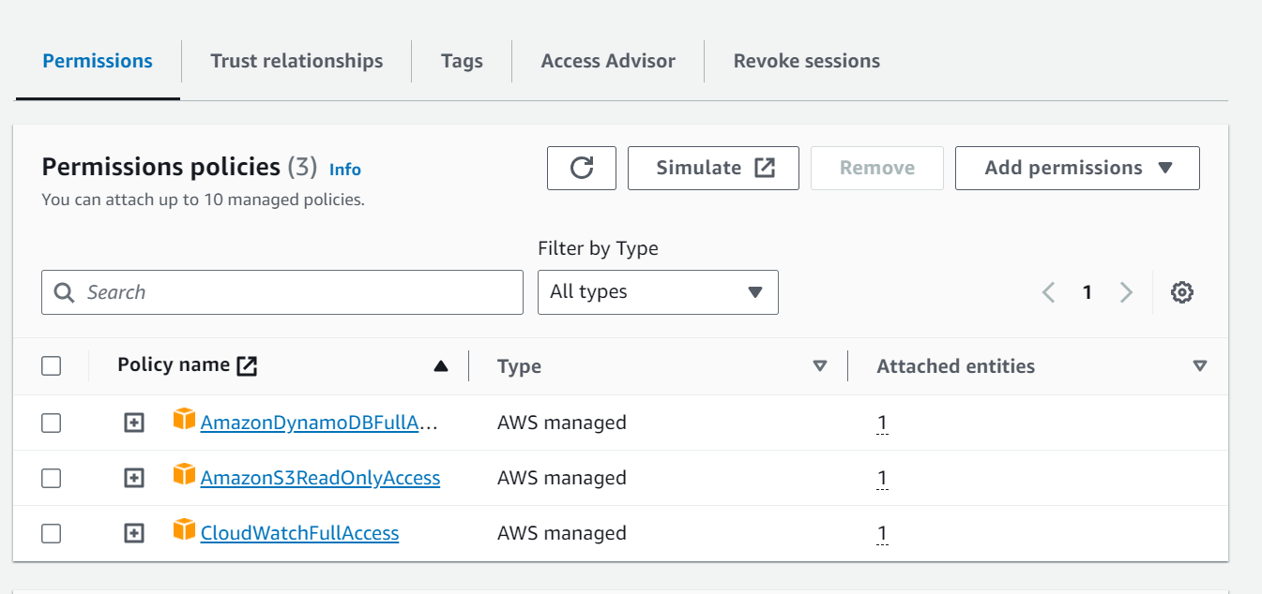

1. Create S3 bucket

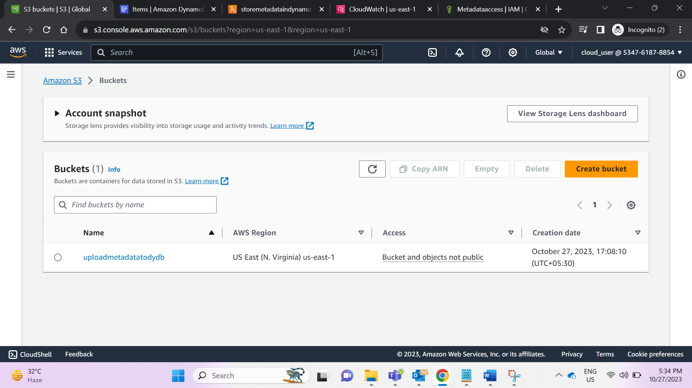

1. Create DynamoDB with Partition key

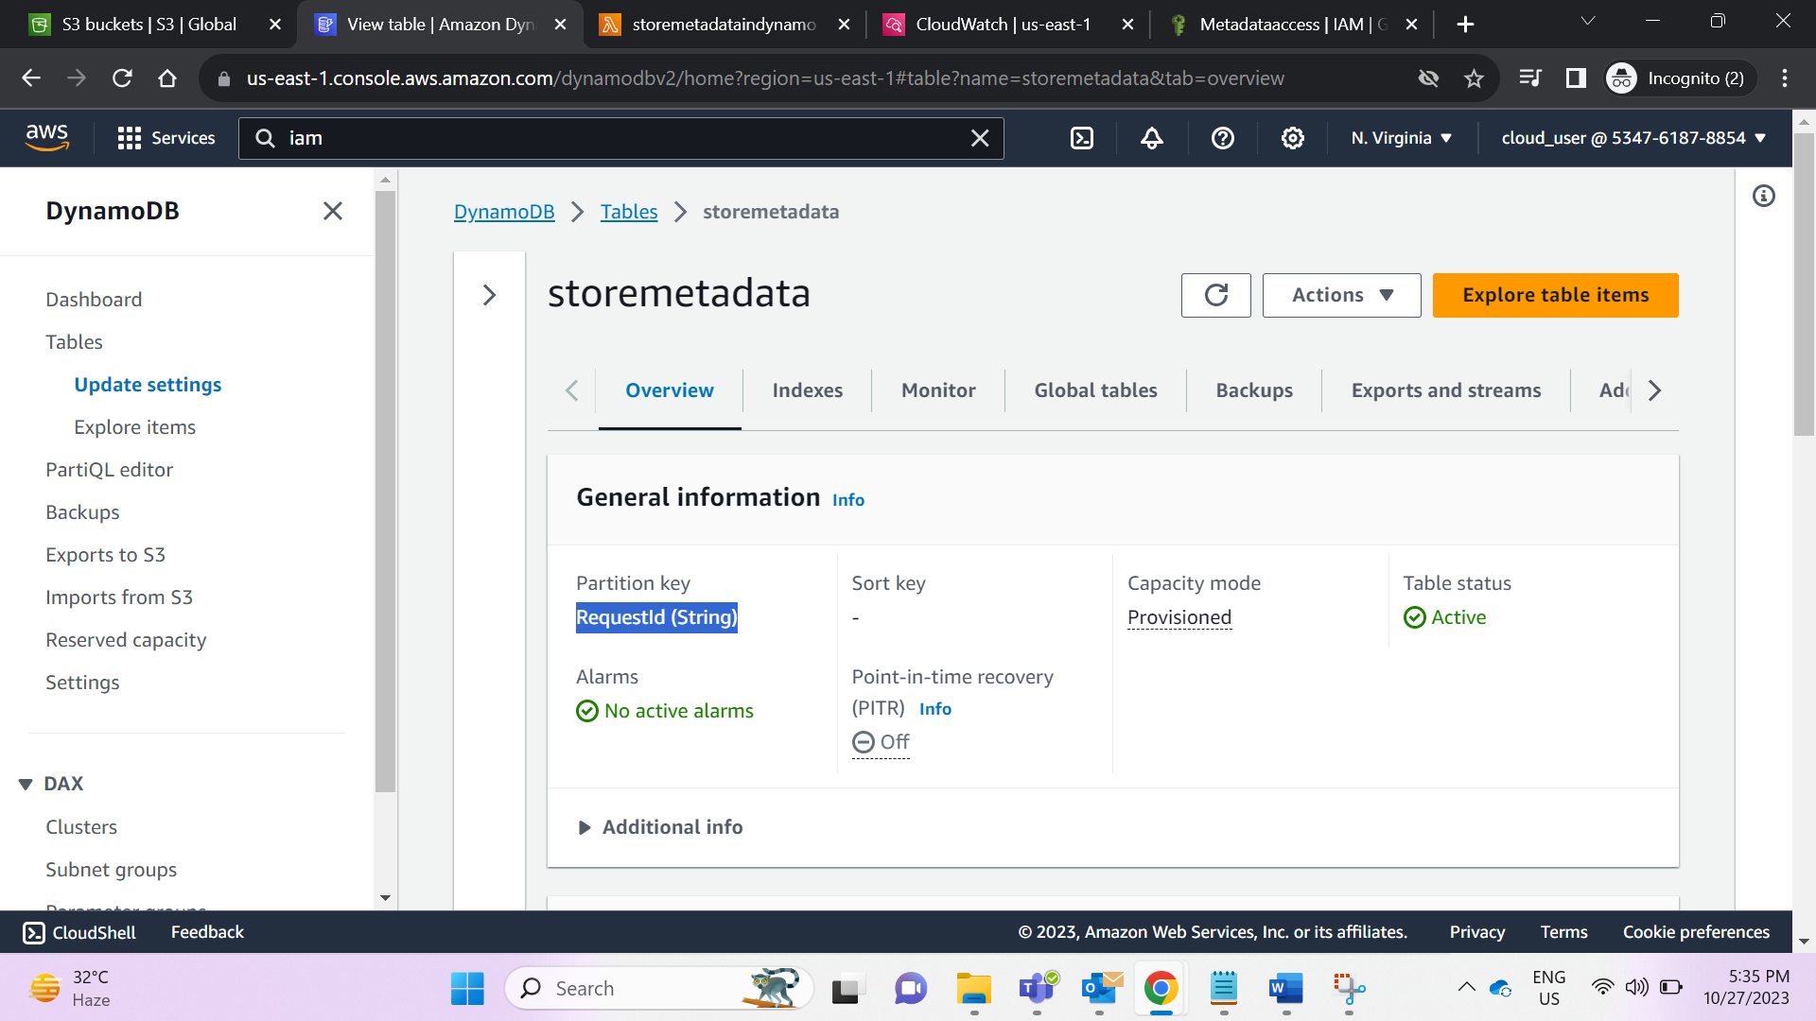

1. Create Lambda function by adding existing Role created above

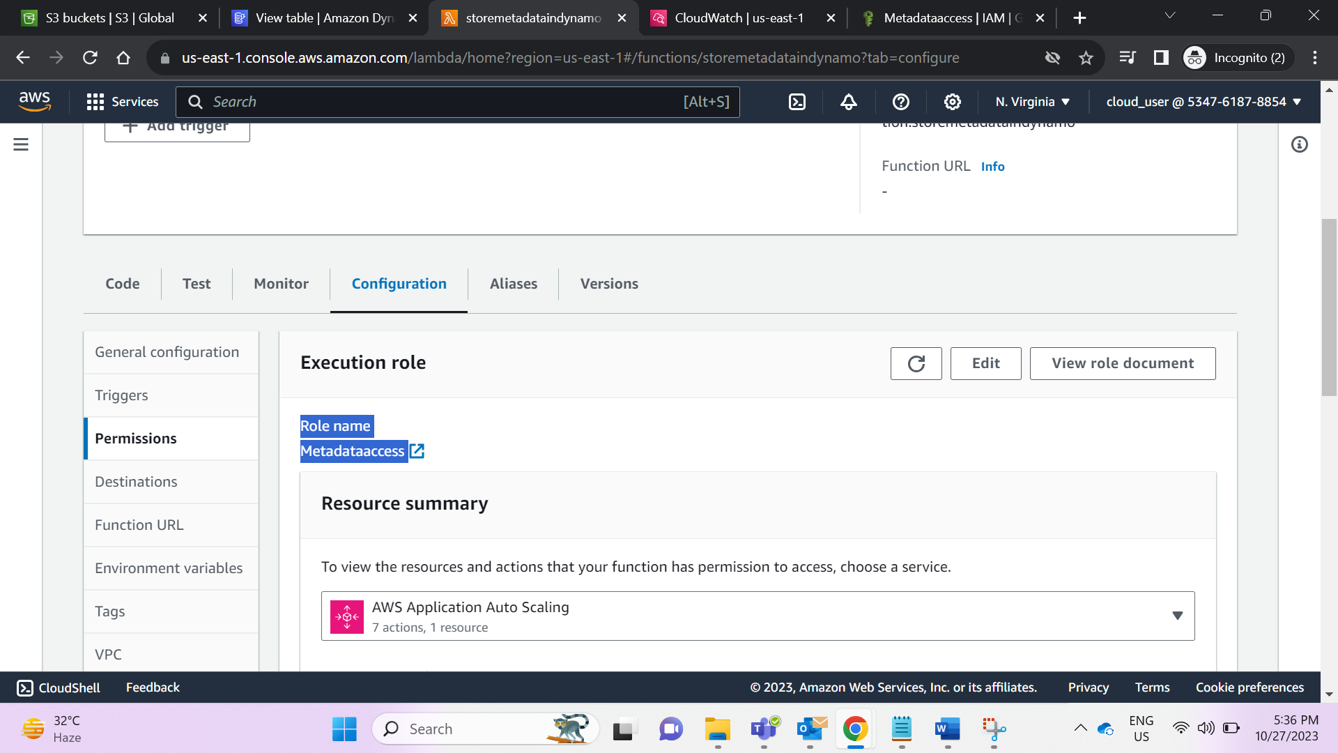

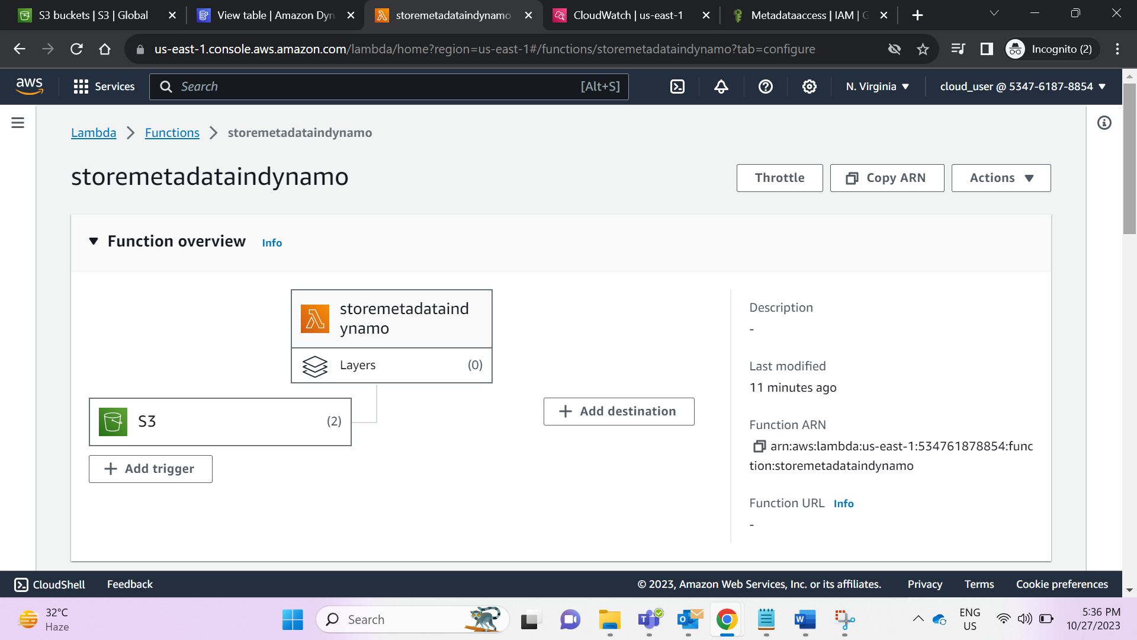

1. Add S3 as triggers: 1 for All object and another for permanently delete event types.

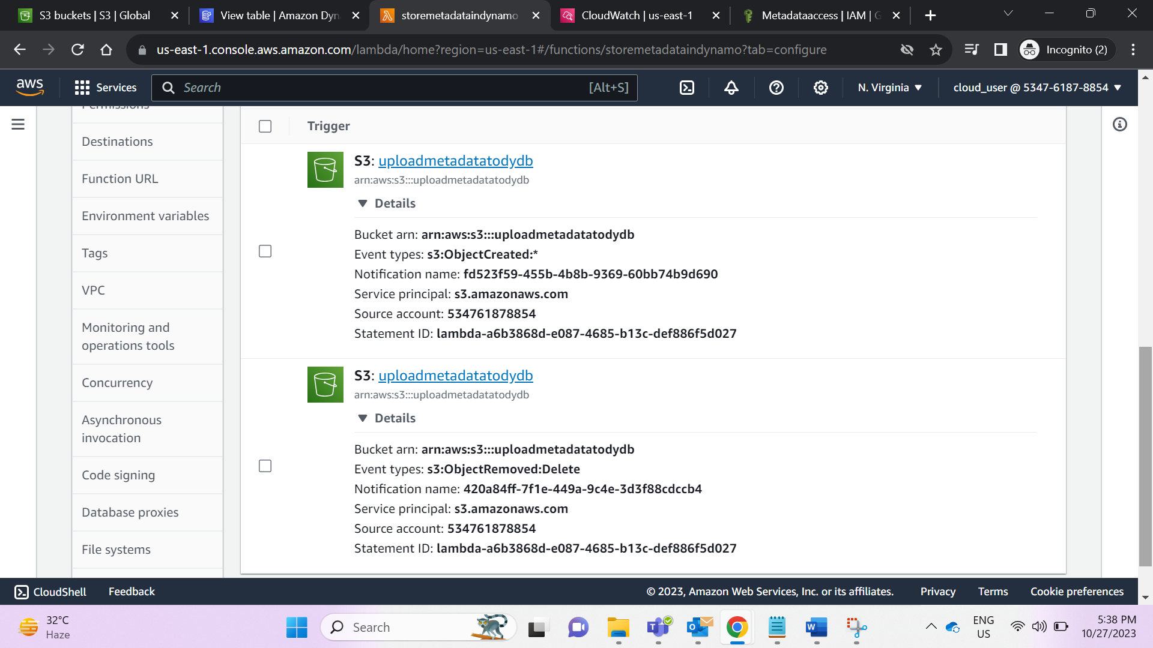6. Upload file in S3 and check the CloudWatch logs

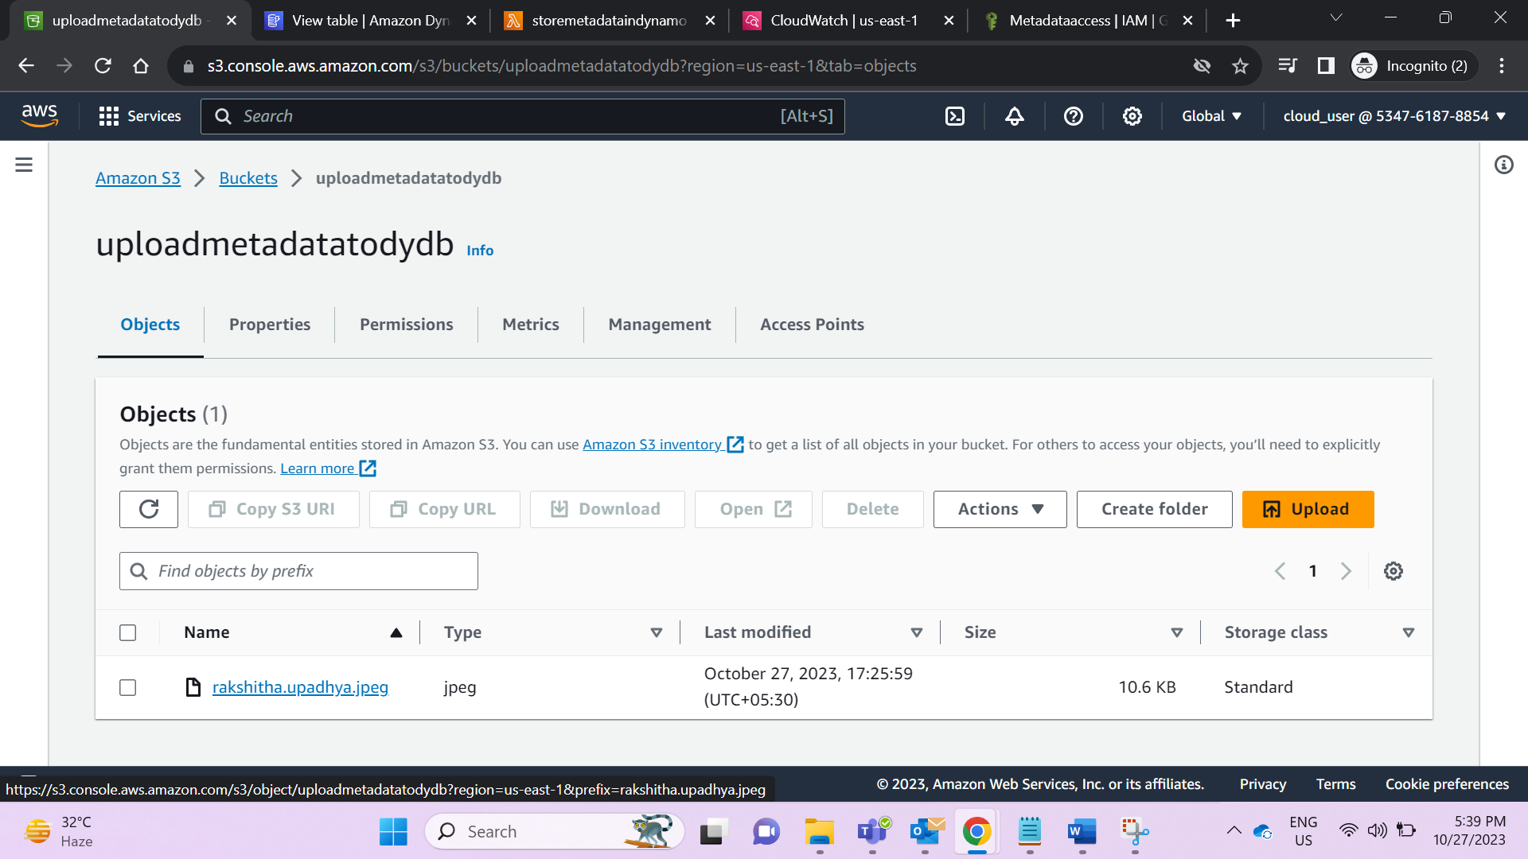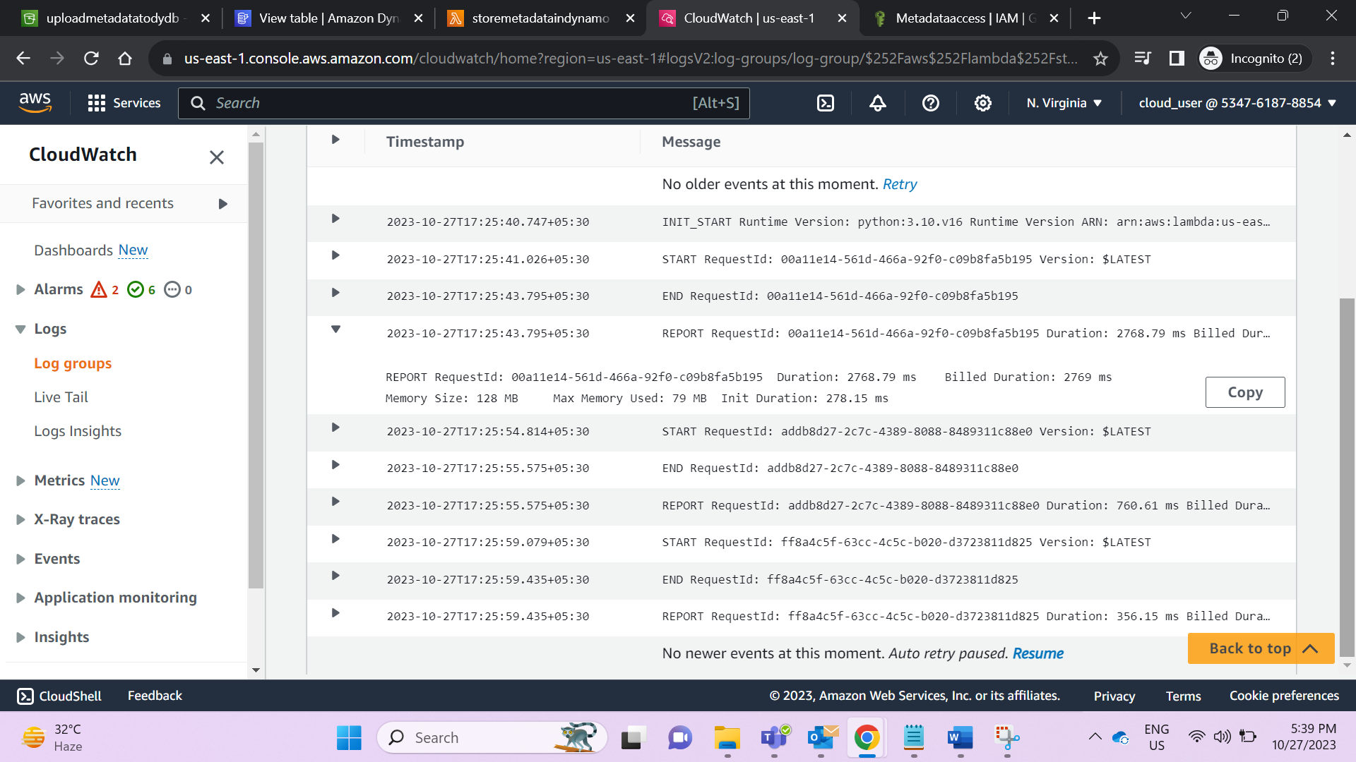

1. Add and delete few files in S3 and check the records in DynamBD

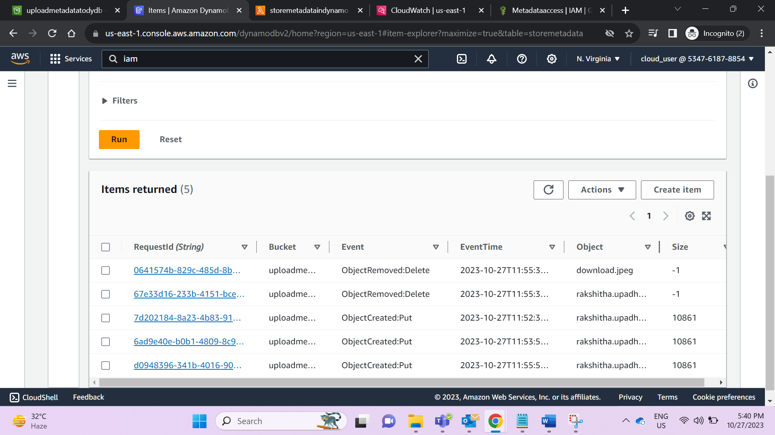

Lambda Code:

Add DynamoDB name & Partition key in the code

Uuid automatically creates random string for partition key – RequestID

size = record['s3']['object'].get('size', -1) – for PUT request size is returned for DELETE request -1 is returned